Wireless adapter-What can I do if the CD is not available?

Product line: wireless Question category：Trouble shooting

In this situation you can do as bellows to download a new driver.
- If the CD is not available, please login to the website: www.mediatek.com
- Then, in the botton of the page, please find Download,then click on your Operating System.
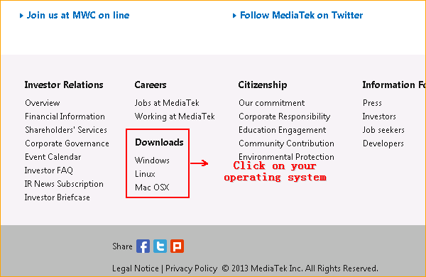

- Choose the driver for your USB or PCI wireless adapter, no matter which operating system, you should choose the first driver for USB or PCI.
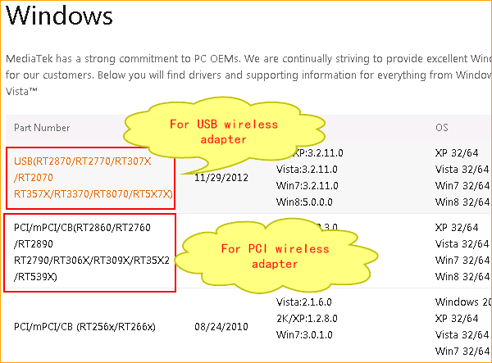

- On the botton of the page, input your name and email, click Submit to downlaod the driver.



